 | Bansilal Ramnath Agarwal Charitable Trust’s Vishwakarma Institute of Information Technology  Department of  Artificial Intelligence and Data Science
Student Name: Sathe Onkar Abasaheb
Class: TY | Division: B |  | Roll No: 372078
Semester: V |  | Academic Year: 2025-2026
Subject Name & Code: Cloud and DevOps
Assignment No: 05
Title of Assignment:Containerization with Docker – Install Docker, create containers, manage images, and use volumes

Date of Performance: / /2025 |  | Date of Submission: / /2025

1. Introduction
Containerization is a lightweight form of virtualization where applications and their dependencies are packaged together in isolated units called containers. Unlike virtual machines, containers share the host system’s operating system kernel, making them more efficient and portable.
Docker is the most widely used containerization platform. It simplifies application deployment by allowing developers to build once and run anywhere.
This assignment explains how to install Docker, create containers, manage images, and use volumes.

2. Objectives
- To understand the concept of containerization and Docker.
- To install and configure Docker on a system.
- To create and run containers.
- To manage Docker images effectively.
- To use Docker volumes for persistent storage.

3. Procedure

Step 1: Install Docker
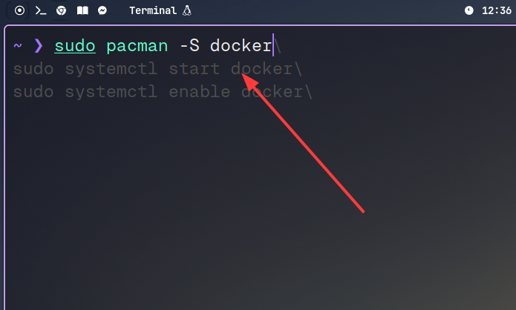
- Step II: Verify Installation
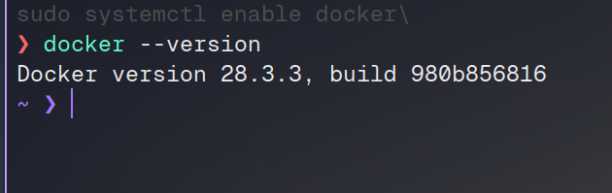
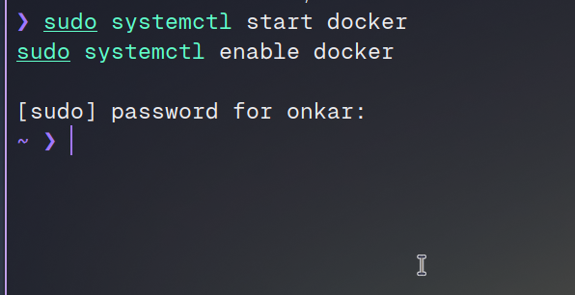
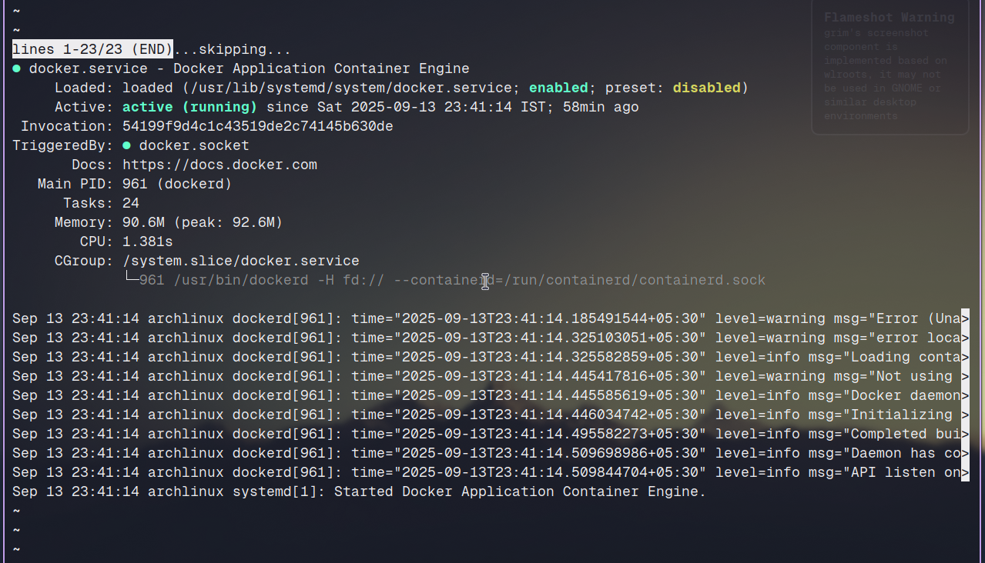
3. Step II: Enable Docker
4: Enable Docker amd check service (disable default)

